Pre-Incident Public Information Materials for CBRNe Incidents

If you think you have been exposed to a potentially harmful substance, you should move away from the hazard as soon as possible to prevent further exposure.

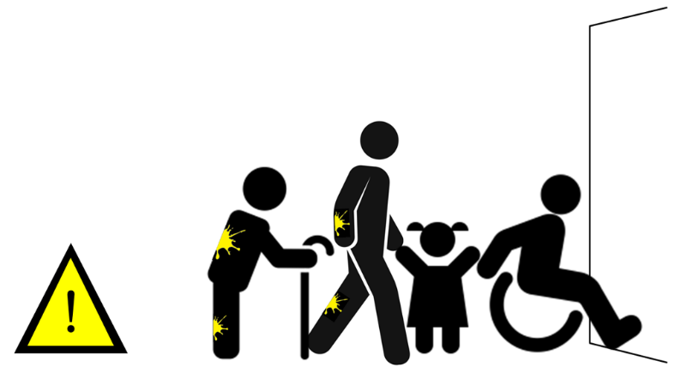

You should remain near the scene as emergency responders will soon arrive to help you. While you are waiting:
- Get fresh air if possible – this can help with any symptoms you may be experiencing. Do not eat, drink, smoke or touch your face to avoid swallowing any of the potentially harmful substance.

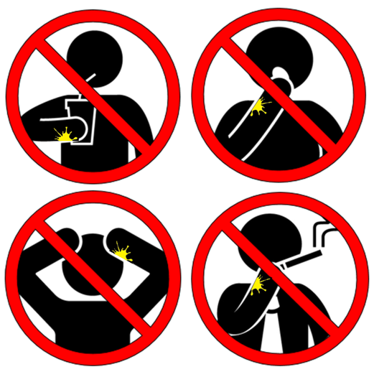

- Remove your outer clothing. Your outer clothing may have some of the potentially harmful substance on it, and so removing this will help to reduce your exposure to the substance. Try to remove clothing without pulling any clothes over your head, if possible. If this is not possible, try to avoid clothing coming into contact with your face whilst removing over your head.
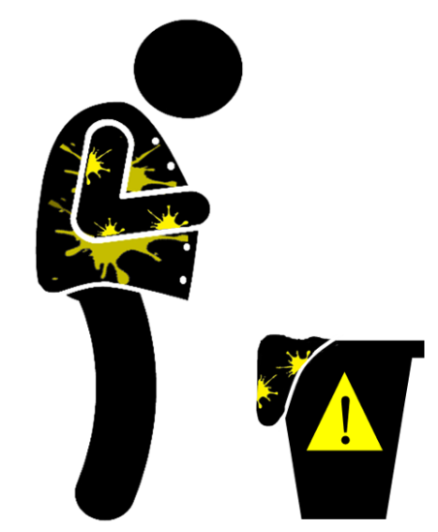

- If any of your skin has the potentially harmful substance on it, use a dry tissue or similar absorbent materials to either soak it up or brush it off. This will help to remove the substance from your skin. If your skin is itchy or burning, then rinse the affected area continually with as much water as possible.
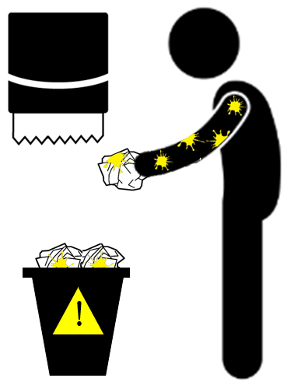

- When emergency responders arrive, they may ask you to remove your clothing to your underwear and then wash yourself all over in a shower system that they will set up at the scene.
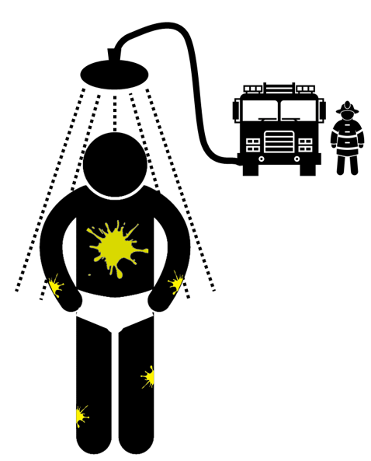

- You should not put your old clothes back on after removing the substance from yourself. Emergency responders will help to provide you with clean, uncontaminated clothing.
