Pre-Incident Public Information Materials for CBRNe Incidents

The information in this document outlines the steps you can take to protect yourself in the initial stages of an incident involving the release of a hazardous substance. Emergency responders refer to these as CBRNe incidents - where the letters stand for Chemical, Biological, Radiological, Nuclear, or explosive (CBRNe). The incident described in the following scenario is an example of this type of incident:

Mid-morning, you and other passengers, are awaiting to board a train at a Railway Station when there is a loud noise from up the railway track followed by a cloud of gas which drifts onto the platform. The passengers show signs of irritation, such as coughing, breathing difficulties, and streaming eyes.

In this example, a hazardous substance may have been released, and is causing symptoms in the passengers. The information on the following pages outlines steps you can take in this scenario.

Please note: The yellow splodges in the following images represent a hazardous substance and indicate danger. In reality, some harmful substances may not be visible.

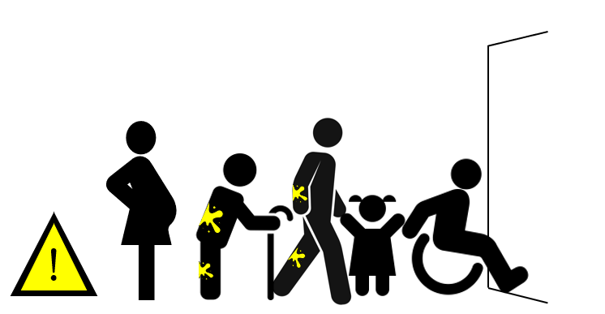

If you think you have been exposed to a potentially harmful substance, whether you can see it or not, move away from the hazard as soon as possible to prevent any further contact with the substance. Get fresh air if possible – this can help with any symptoms you are experiencing.

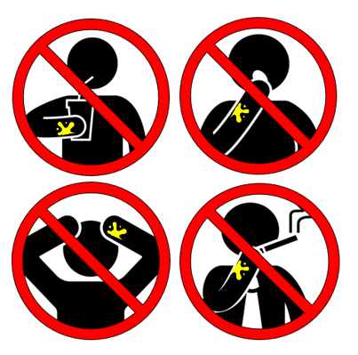
While you should move away from the hazard, you should remain in the general area as emergency responders will soon arrive to help you. While you are waiting you should avoid doing the following things:
- Do not eat, drink, smoke or touch your face to avoid swallowing any potentially harmful substance.
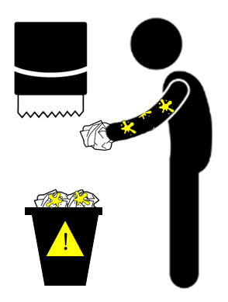
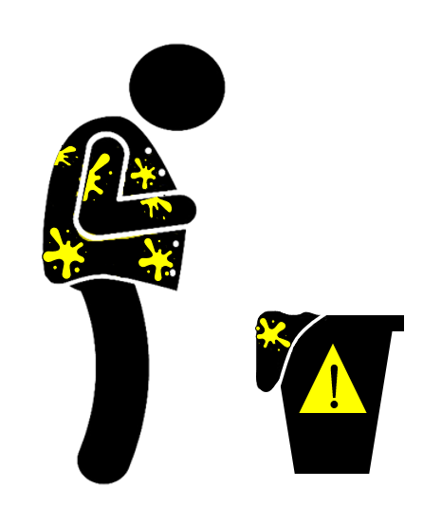
- Remove your outer clothing. This will help to remove any harmful substances. Remember that not all harmful substances will be visible, so you should remove your outer clothing even if you think there isn’t any substance on you. When removing your outer clothing try to avoid pulling any clothes over your head. If this is not possible, try to avoid clothing touching your face whilst removing over your head.
- If any of your skin has the potentially harmful substance on it, use a dry tissue or similar absorbent materials to either soak it up or brush it off. This will help to remove the substance from your skin. If your skin is itchy or burning, then rinse the affected area continually with as much freshwater as possible.
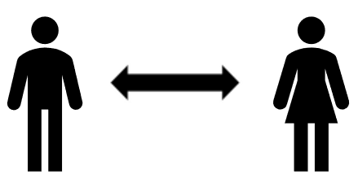

- Avoid coming into contact with other people, where possible, to prevent spreading any substance.
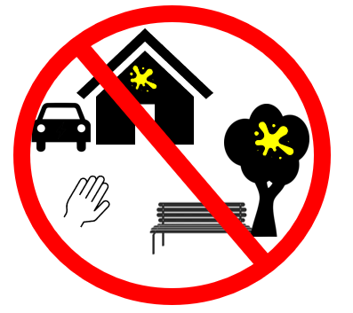
- Minimise contact with your surroundings. Not all hazards are visible.

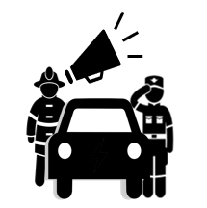
- When first responders or authorities arrive, make sure you listen to any instructions they give you. Tell them if you have a vulnerability which may impact your ability to complete the instruction. Responders will also provide specialised assistance to vulnerable individuals.
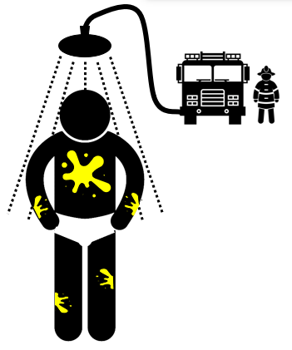

- Emergency responders or authorities may also ask you to remove your clothing to your underwear and then wash yourself all over in a shower system that they will set up.

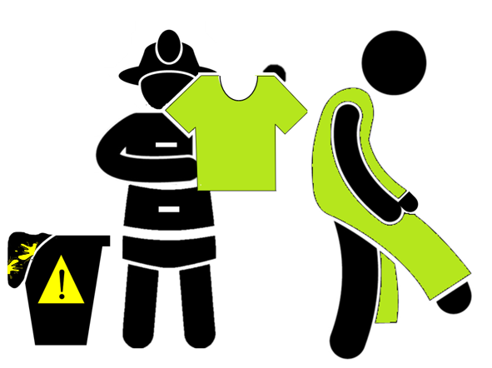
- You should not put your old clothes back on after removing the substance from yourself. Emergency responders will help to provide you with clean clothing.
To protect yourself in a CBRNe incident, remember to:
- Move away from the hazard as soon as possible
- Do not eat, drink, smoke or touch your face
- Remove your outer clothing, try to avoid pulling any clothes over your head
- Use a dry tissue or similar absorbent materials to either soak up or brush off the hazardous substance
- Continuously rinse your skin with water if you have symptoms of itching or burning
- Avoid coming into contact with other people
- Minimise contact with your surroundings
- Make sure you listen to instructions from emergency responders. Tell them if you have a vulnerability which may impact your ability to complete the instruction.
- Remove your clothing to your underwear and then wash yourself all over in the shower system set up by emergency responders
- Do not put your old clothes back on after removing them

